Appendix 1:
Tectonic scheme of Kamchatka
Geological setting of the sampling area
Description of the sampled sites
Fig. 16. Tectonic scheme of Kamchatka, after (Konstantinovskaja, 2003; Geological map..., 2005), changed and complemented by the authors. Blocks with continental crust: SM - Sredinny Massif; GB - Ganal block, KhU - Khavivenskaja Upland. Contemporary volcanic belts: EVF - Eastern Volcanic Front; CKD - Central Kamchatka Depression; SR - Sredinny Range; SK - South Kamchatka.
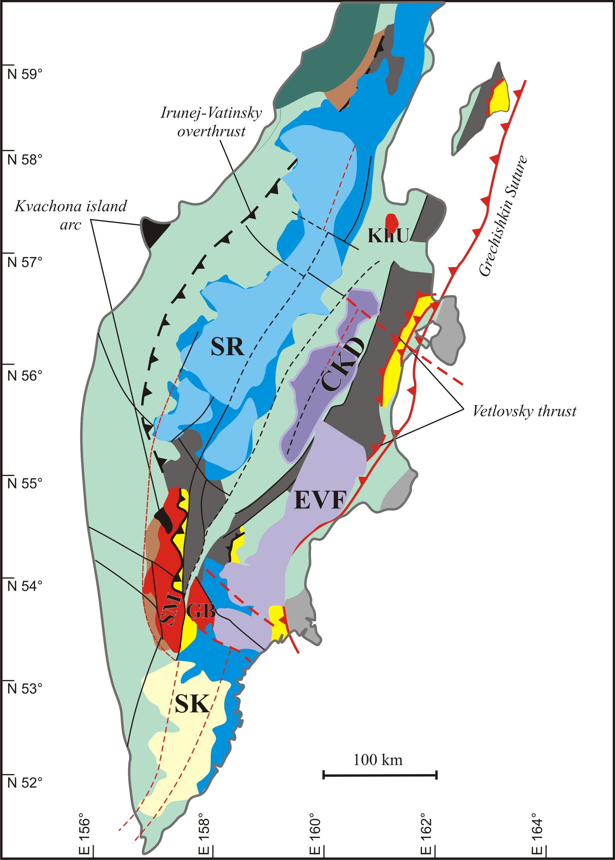
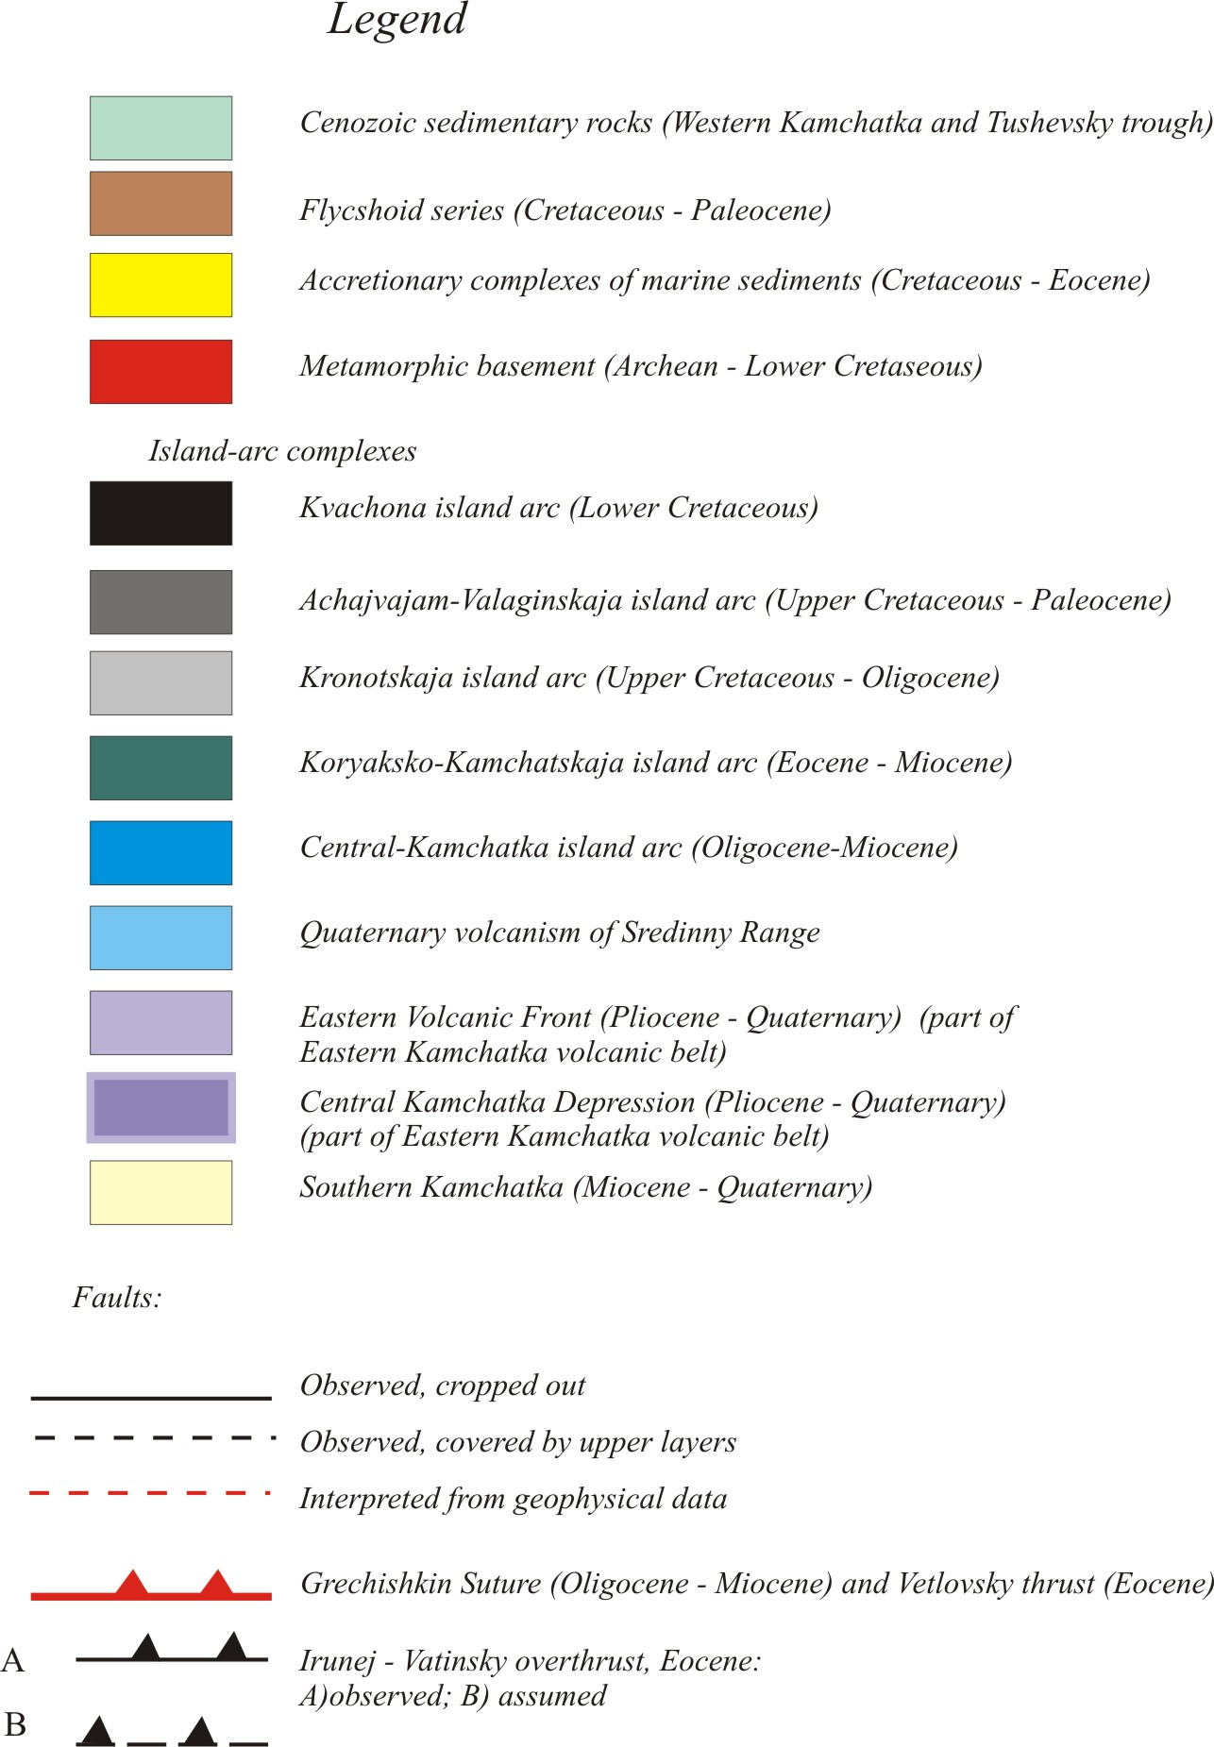
Appendix 1.
Geological setting and sampling.
The overview of the sampling area is shown at the following figure and the detailed descriptions are given below.
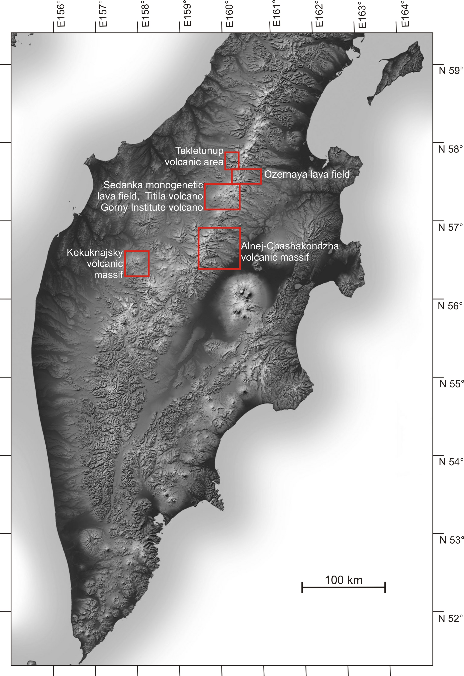

The glacier-capped Alnej-Chashakondzha massif, one of the largest volcanoes of Sredinny Range, is located in the northern part of the Sredinny Range at the latitude of Shiveluch Volcano, 100 km to the west. It is surrounded by monogenetic cinder cones and lava flows. Two Holocene lava flows (Kireunsky and Left Belaja river lavas) and several Late Pleistocene monogenetic lava flows, including Mount Chernaya 13 km N of Alnej, have been sampled here, as well as an older lava flow, which possibly represents the shield basement under the younger edifices. Pliocene lavas of the Kruki Ridge, situated 25 km to the south from Alnej volcano, and plateau basalts of Dvuh’urtochnoe lake, about 30-40 km north-east from Alnej volcano, have also been sampled.
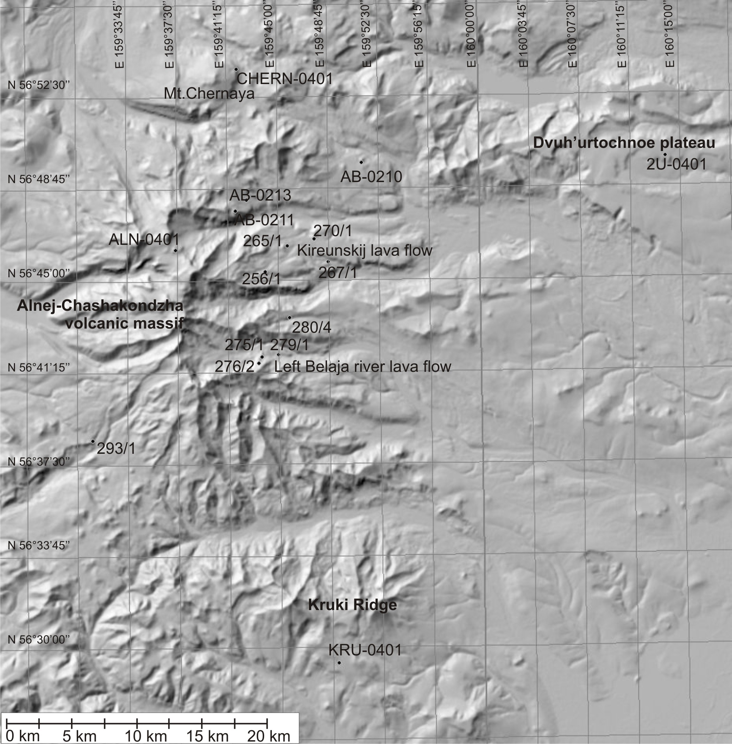

The Mt. Bolshaya-Kekuknajsky volcanic massif is situated at the western foothills of the SR, 200 km to the west of Shiveluch volcano where several well-preserved lava flows and cinder cones were sampled. According to tephrochronological data and indications for glaciation, these lava flows were formed during the last glacial period (~10000 14C years B.P.) (Pevzner 2004).
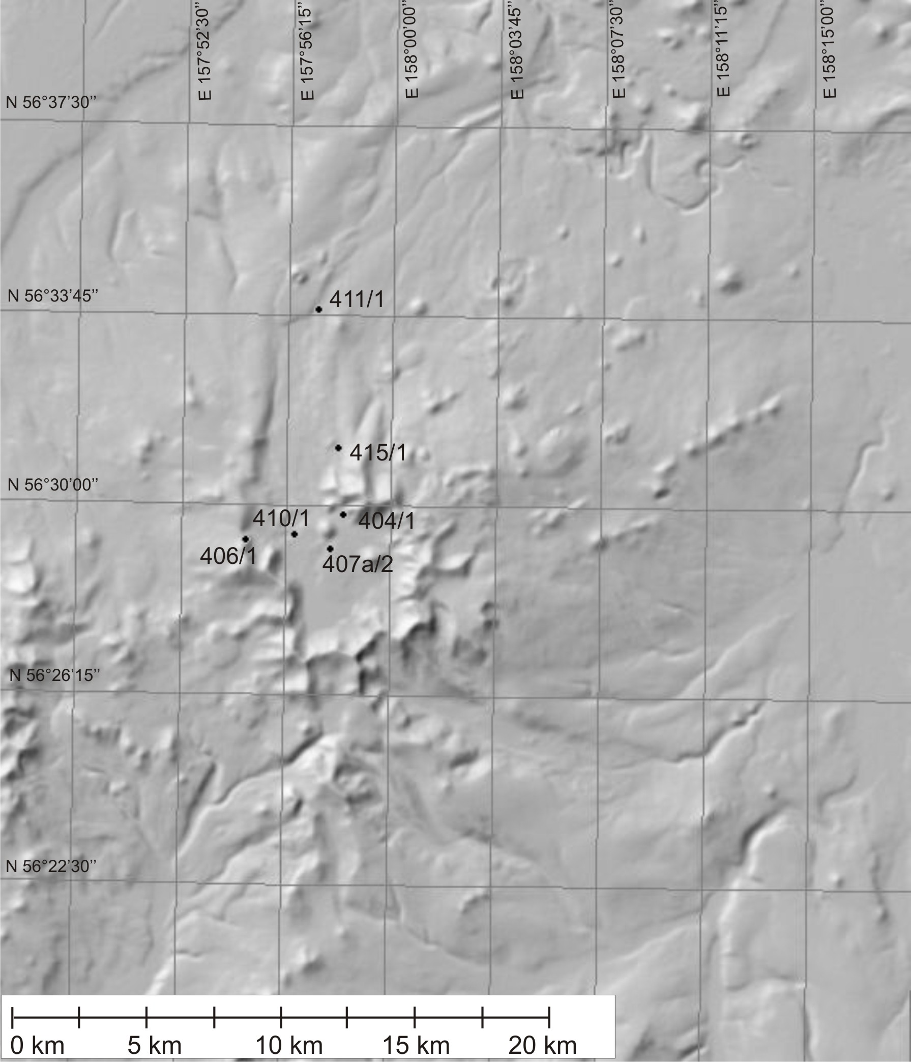
The Sedanka monogenetic lava field represents area with the most abundant monogenetic activity in the northern part of the SR. Within this area there are several shield volcanoes of Iceland type (simple and most symmetrical shield volcanoes, formed entirely or almost entirely by effusive eruptions from central summit-vents; range in height between 50 and 1,000 m, averaging 350 m) (Titila, Leutongey, Tuzovsky, Tvitunup, Terpuk) and around 100 monogenetic cones (Ogorodov et al. 1972). The youngest eruptions here took place in the Late Holocene (Dirksen et al. 2004). Numerous monogenetic lava flows of Late Pleistocene-Holocene age, products of the series of eruptions of Titila shield volcano and older basement lava shield have been thoroughly sampled.
Gorny Institute volcano lies 105 km to the west from Shiveluch volcano. A series of Late Quaternary lava flows and more silicic pyroclastic flow deposits were sampled on its southwest slope and provided for this study by Dr. Pevzner M.M.
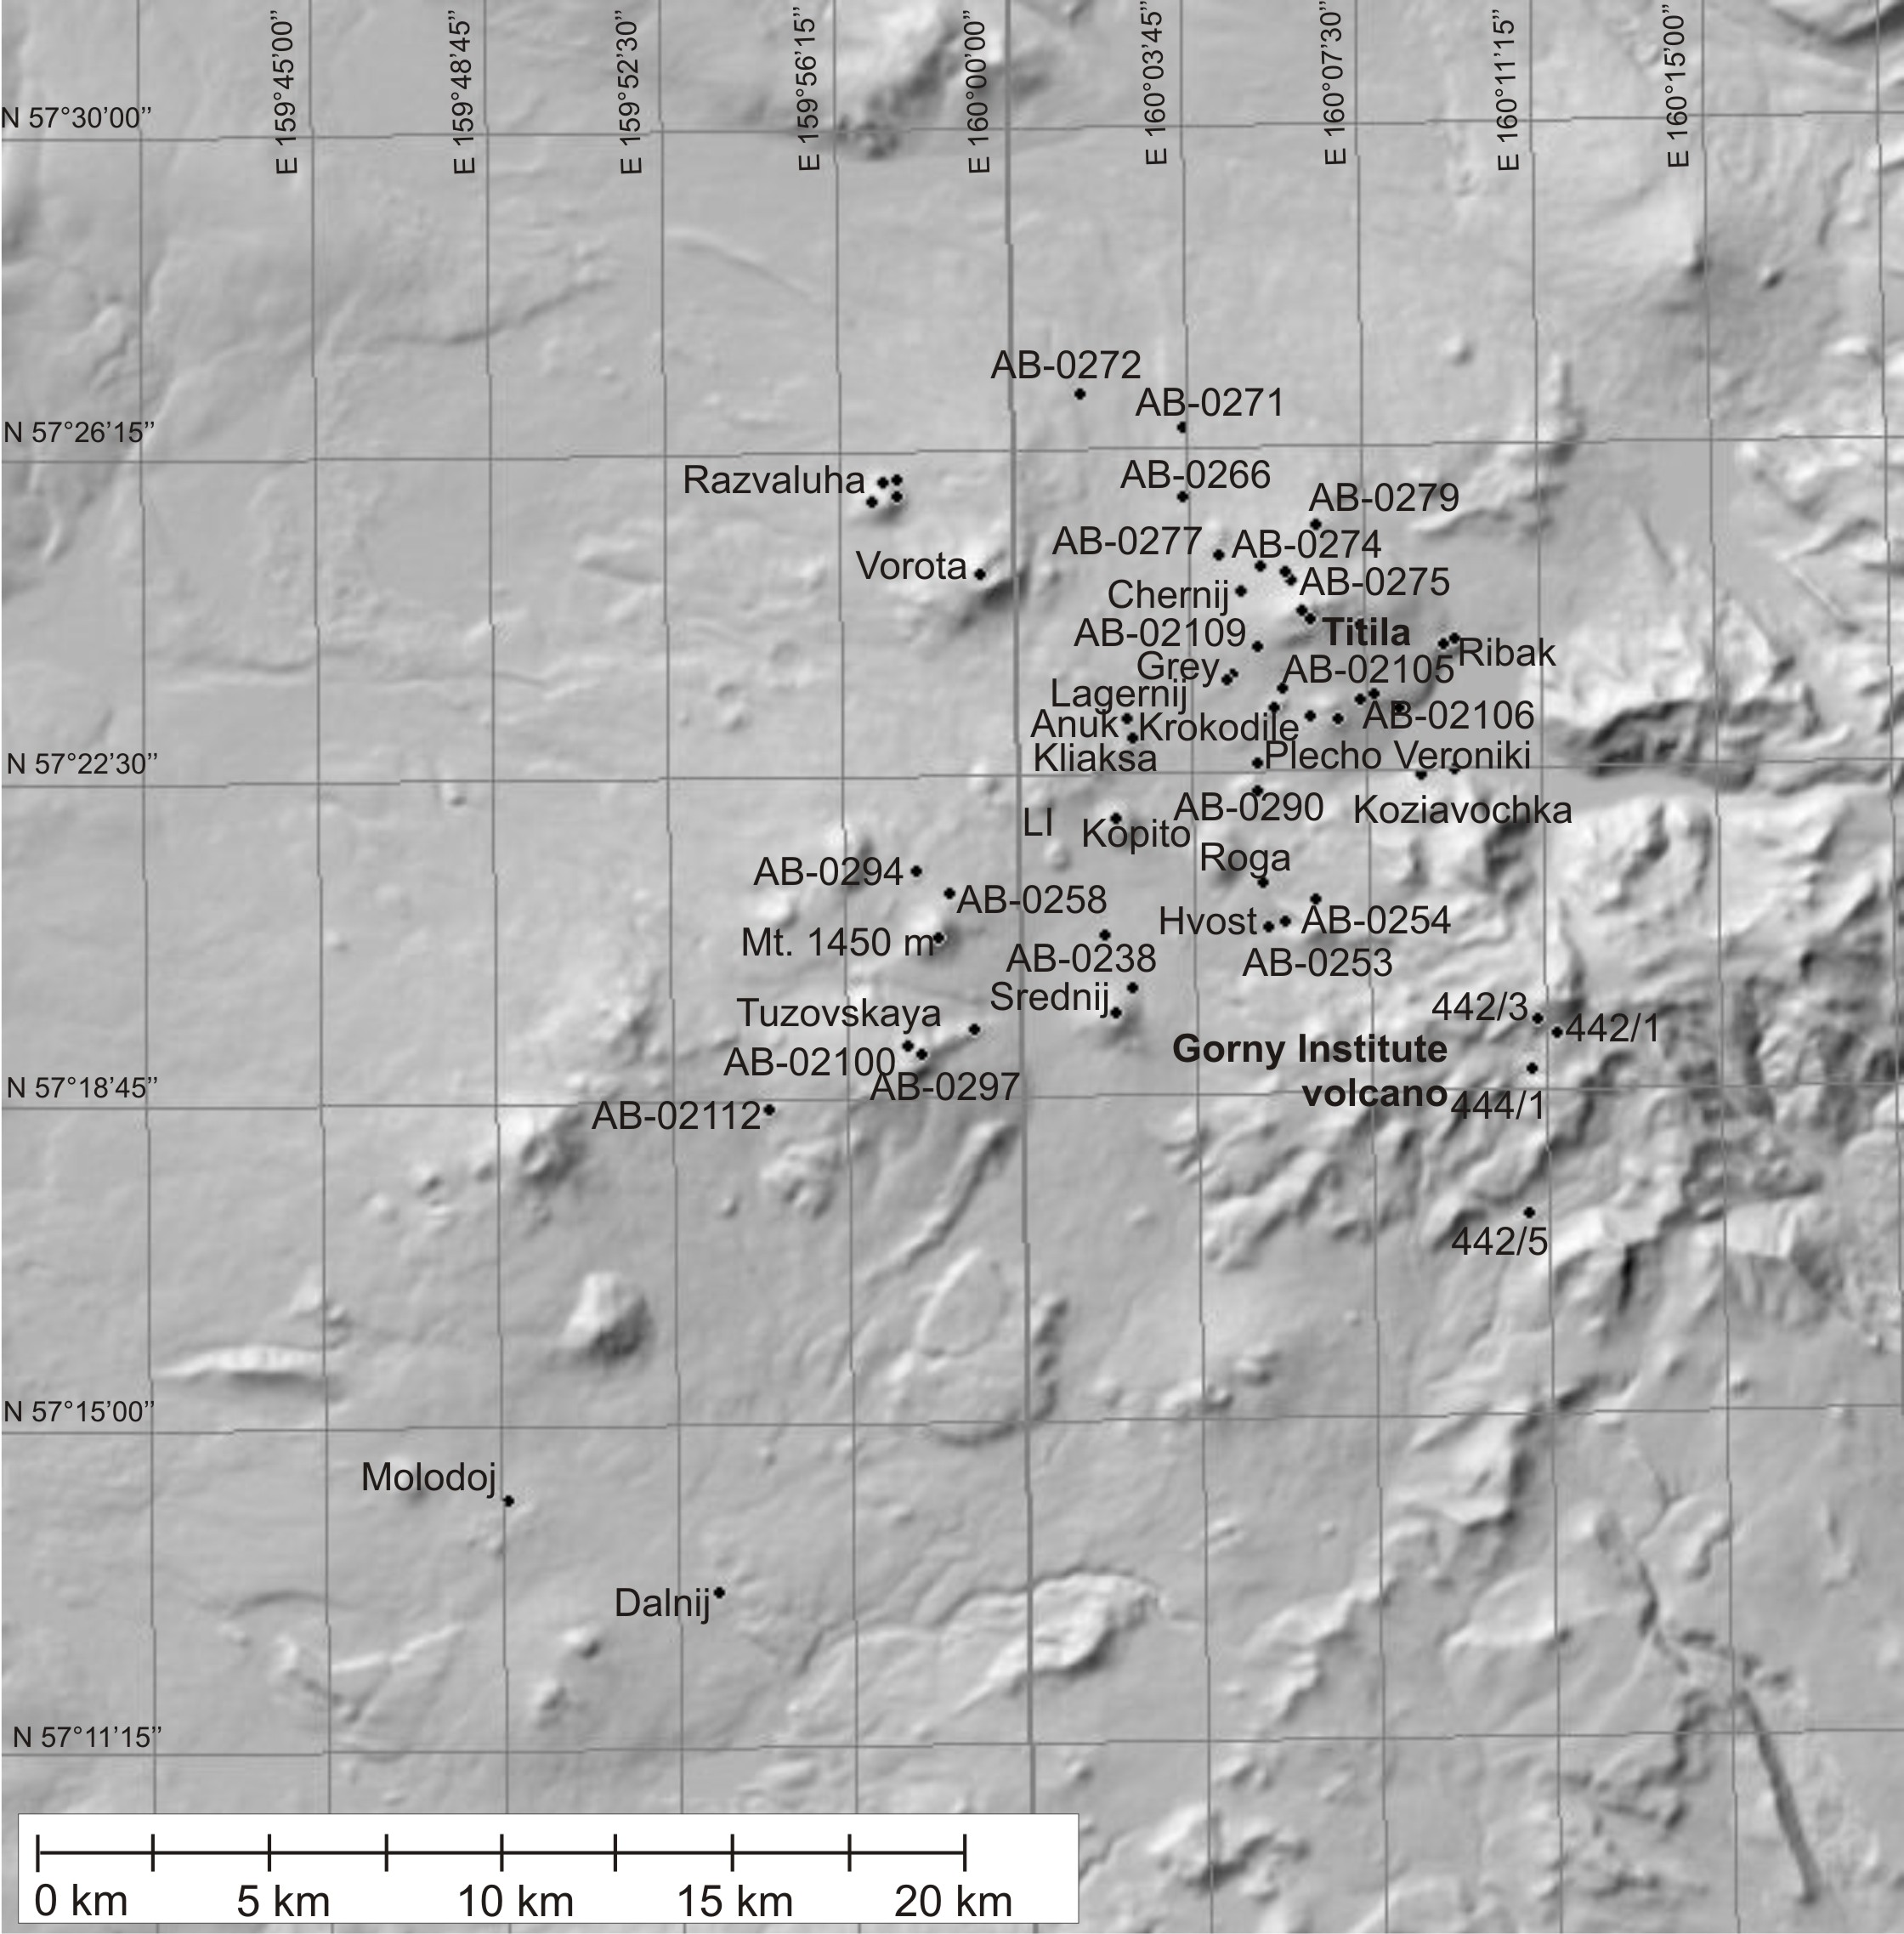
Late Miocene-Pliocene Left and Right Ozernaya Plateau (hereafter LOP and ROP, respectively) and Late Pleistocene-Holocene monogenetic lava field are situated in the eastern offset of Sredinny Range of Kamchatka, in the upper reach of Left and Right Ozernaya rivers. The thickness of the plateau in the upper reach of the rivers is about 300 m. Numerous well-preserved monogenetic cones appear on the surface of the plateau as a result of younger volcanic activity. Monogenetic lava flows and cinder cones constructed on the Right Ozernaya Plateau have been sampled for this study (ROM = Right Ozernaya Monogenetic field), as well as underlying plateau basalts. Dr. Ladygin V.M. kindly provided us with samples of Left Ozernaya Plateau basalts.
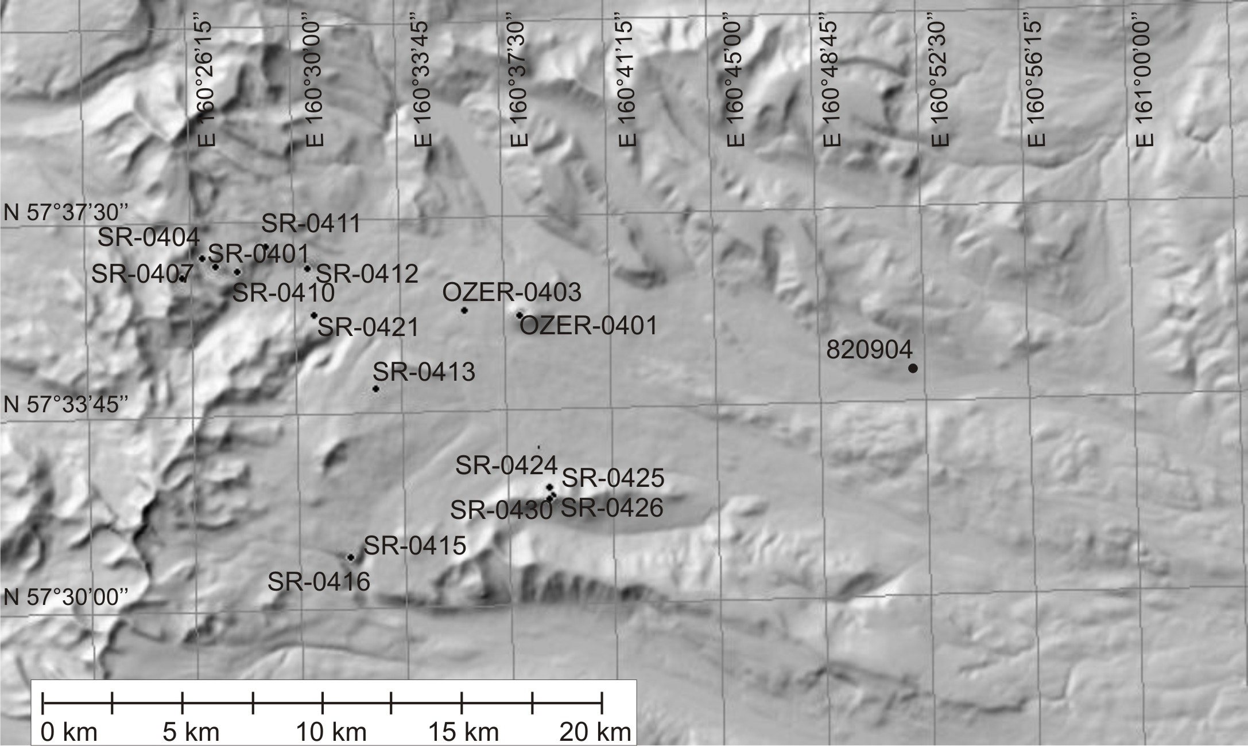

The Tekletunup volcanic area completes our sampling transect to the north. Dr. Perepelov A.B. kindly provided samples of volcanic rocks of Pleistocene cinder cones and Plosky volcano for this study.
