УДК 624.04

**Расчет прогиба стержневой рамы**

*Кирсанов Михаил Николаевич*

*НИУ "МЭИ",*

*профессор*

*Разананирина Ранди Кедрик*

*НИУ "МЭИ",*

*студент*

**Аннотация**

Статически определимая плоская симметричная рама закреплена на четырех опорных стержнях и нагружена по верхнему поясу. Дается вывод формулы для прогиба средней точки ригеля. Замечено, что при нечетном числе панелей по высоте рамы, независимо от числа панелей в пролете, определитель системы уравнений равновесия узлов, из которой находятся усилия в стержнях, обращается в ноль. Для обобщения формула для прогиба на произвольное число панелей в пролете для двух панелей по высоте применяется метод индукции. Прогиб рассчитывается по формуле Максвелла - Мора в системе Maple.

**Ключевые слова:** ферма, рама, прогиб, метод индукции, Maple

**Calculus of a truss frame flexure**

*Kirsanov Mikhail Nikolaevich*

*NRU “MPEI”*

*Professor*

*Razananirina Randy Cedric*

*NRU “MPEI”*

*Student*

**Annotation**

The statistically determinable flat symmetrical frame is fixed on four support rods and is put under load along the upper belt. It is given a formula for the middle point flexure. It is noticed, that for an odd number of panels along the frame height, independently from the panel number in width, the determinant of the nodes’ equilibrium system of equations, from which the forces in the rods, equals zero. The induction method is used for the general flexure formula for any number of panels in width for two panels in height. The flexure is calculated using the Maxwell-Mohr formula in Maple.

**Keywords:** truss, frame, flexure, induction method, Maple.

The lattice type truss frame (Fig. 1) is externally statistically undefinable. To determine the forces in the four support rods, it is necessary to study the state of equilibrium of all the truss nodes, or alternatively apply the method of possible displacements. The horizontal part of the frame (crossbar) consists of 2*n* panels, counting along the lower belt, having a length *a* and height *h*. The number of rods in the frame – *N*=8(*n+m*)+20, where *m*=2 – number of panels along the frame height.

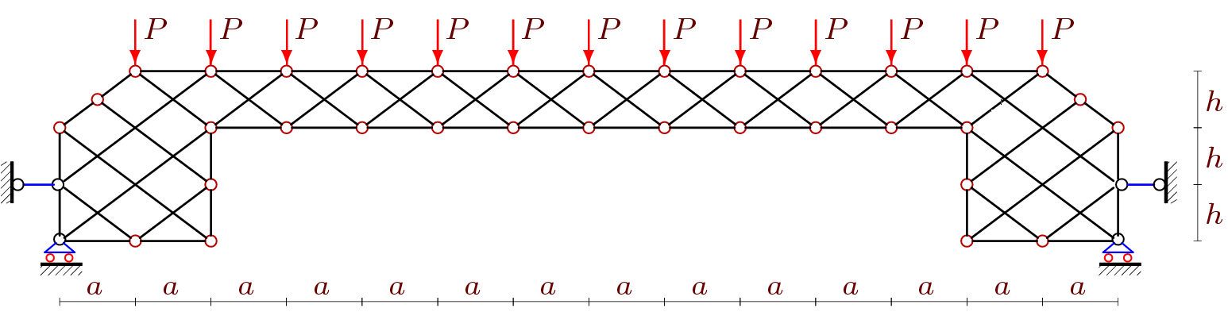

Figure 1 — Frame for *n*=5, *m*=2.

The flexure is determined by the Maxwell-Mohr formula. For that, it is necessary to acknowledge the forces inside the rods. The force values are obtained in its symbolic form in the program [1]. Rods and nodes are numbered (fig.2):

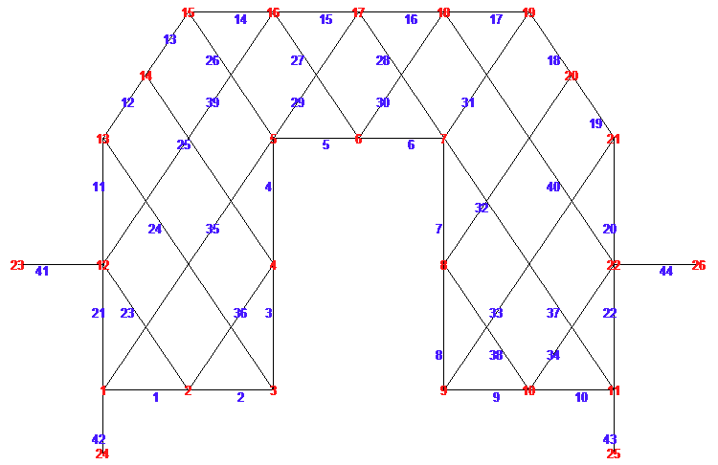

Figure 2 — Rod and Node Numbering, *n*=1, *m*=2.

In the program, the connection order of rods and nodes is also given:

> **q:=2*n+2*m:**

> **for i to q+4 do**

**N[i]:=[i,i+1];**

>  **N[i+q+4]:=[i+q+5,i+q+6];**

> **end:**

> **N[2*q+9]:=[1,q+6]:N[2*q+10]:=[q+5,2*q+10]:**

> **for i to m+2*n+2 do**

**N[i+2*q+10]:=[i+1,i+q+5];**

**N[i+6*n+5*m+12]:=[i+m+2,i+3*m+2*n+8];**

**end:**

> **for i to m-2 do**

**N[i+8*n+6*m+14]:=[i+q+5,i+5];**

**N[i+8*n+7*m+12]:=[i+3*m+4*n+12,i+m+2*n+2];**

**end:**

> **for i to 2 do**

**N[i+4*q+10]:=[i,6-i];**

**N[i+4*q+12]:=[q+i,q+6-i];**

**end:**

**N[4*q+15]:=[3*m+2*n+4,3*m+2*n+8]:**

**N[4*q+16]:=[3*m+4*n+8,3*m+4*n+12]:**

From this, matrix of the coefficients of the equilibrium’s system of equations for the nodes data is formed. The system’s solution is obtained in the symbolic form using the inverse matrix method, which in Maple is realized way faster compared to other methods, and the transformation speed in this type of task has a significant value. To calculate the flexure,the Maxwell-Mohr formula in the next form is used:

 (1)

where — rod section area, — rod modulus of elasticity,  and — length of j-th rod and the efforts in it from the action of a distributed load, — efforts from a single vertical force, applied to the mid-span on the lower belt. The summation is carried out over all of the frame rods, except the four support ones, that are considered stiff.

The analysis of the series of solutions for the truss with a number of panels from 1 to 18 showed, that the formula for the flexure has the same form:

. (2)

Using the Maple system operator **rgf_findrecur**, it turns out that the sequence 12, 142, 208, 808, 1060, 2734, 3360, 6968, 8220, 14878, 17072, 28152, 31668, 48798, 54080, 79144 coefficients for corresponds the ninth order homogeneous linear recurrent equation



The solution of this equation with the initial conditions



is the polynome



Analogically, from the equation



is determined the coefficient



And from the relatively simple equation



we obtain the solution



The solution of the problem of truss flexure is obtained this way for any given number of panels in the girth rail.

On Fig. 3 are shown graphs of obtained solutions for the dimensionless flexure , calculated for constant truss span length *L*=100 м*, *and total load*.*

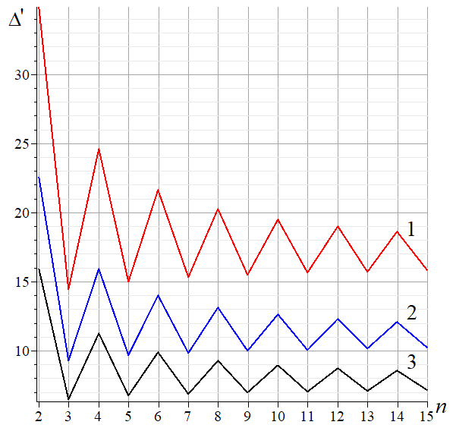

Figure 3. — Flexure in function of the panel number

It should be noted that the characteristic flexure jumps in such lattice trusses, decrease with increasing panel number. On the other hand, such jumps allow the possibility to smartly choose the optimal panel number at a fixed span. It is enough to just change this number by one unity to decrease the flexure by one and half or even two times. The dependence of the flexure in function of the height is shown graphically on Fig. 4.

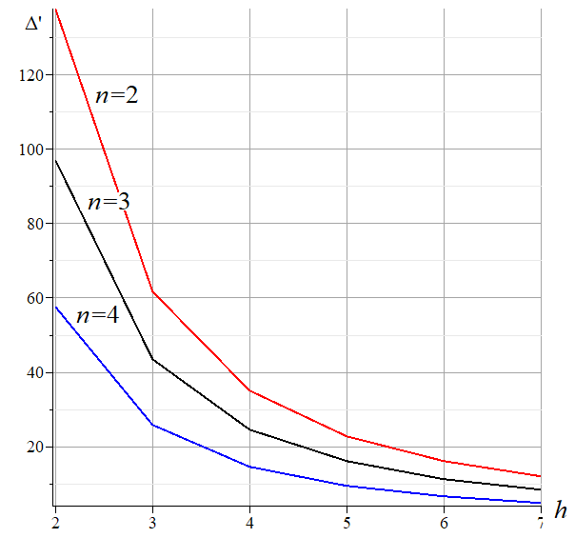

Figure 4 — Dependence of the flexure in function of the truss height, *L*=100m

The truss is calculated for an even panel number *m*=2 in height, however the attempt of obtaining a solution for an odd panel number was unsuccessful.

The system of equations degenerates, which indicates the kinematic variabilities of the system (fig. 5).

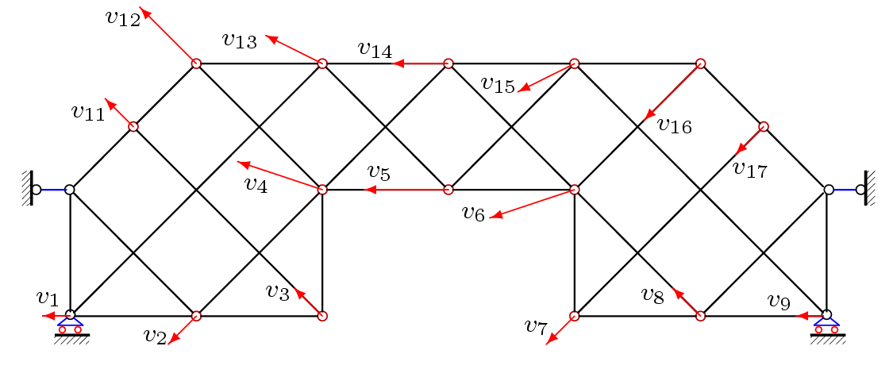

Figure 5 — The distribution of the virtual velocities of the nodes of the variable frame, *m* = 1

An external statistically defined truss with analogic lattice is analogically calculated with the same method as in [2]. The induction method, that permits the obtention exact solutions for any panel number, was earlier used in the solution of problems for flat and three-dimensional trusses. [8,9]. The overview of some works on this topic are shown in [10-12]. Problems of statistically defined regular trusses are discussed in [10,13].

A solution similar to (2) for the considered frame was obtained in [14].

**References**

1. Кирсанов М. Н. Задачи по теоретической механике с решениями в Maple 11. М.: Физматлит, 2010. 264 с.
2. Arutyunyan V.B. Double induction for deriving a formula for deflecting a frame truss with an arbitrary number of panels // Postulat. 2018. №7. С. 5.
3. Kirsanov M.N., Astahov S.V. The mathematical model of dome covering industrial facility // Architecture and Engineering, 2017. №2(2). Pp.8–14. doi: 10.23968/2500-0055-2017-2-2-8-14
4. Кирсанов М.Н., Москвин В.Г. Деформации плоской фермы с усиленной решеткой // Строительная механика и расчет сооружений. 2018. №4(279). С.10-14.
5. Кирсанов М.Н., Хроматов В.Е. Моделирование деформаций плоской фермы треугольного очертания// Строительная механика и расчет сооружений. 2017. 6(275). С. 24-28.
6. Tinkov D. V., Safonov A. A. Design Optimization of Truss Bridge Structures of Composite Materials // Journal of Machinery Manufacture and Reliability, 2017. Vol. 46, No. 1, Pp. 46–52. DOI: 10.3103/S1052618817010149
7. Тиньков Д.В. Формулы для расчёта прогиба вспарушенной балочной раскосной фермы с произвольным числом панелей// Строительная механика и конструкции. 2016. Т. 2. № 13 (13). С. 10-14.
8. Kirsanov M. N. Stress State and Deformation of a Rectangular Spatial Rod Cover // Scientific Herald of the Voronezh State University of Architecture and Civil Engineering. Construction and Architecture. 2016. No. 3 (31). Pp. 71–79.
9. Kirsanov M. N. Analysis of the buckling of spatial truss with cross lattice // Magazine of Civil Engineering, 2016. No. 4. Pp. 52–58. doi: 10.5862/MCE.64.5
10. Тиньков Д.В. Сравнительный анализ аналитических решений задачи о прогибе ферменных конструкций // Инженерно-строительный журнал, 2015. №5(57). С. 66–73.
11. Осадченко Н.В. Аналитические решения задач о прогибе плоских ферм арочного типа// Строительная механика и конструкции. 2018. Т.1. №16. С.12-33.
12. Осадченко Н.В. Расчёт прогиба плоской неразрезной статически определимой фермы с двумя пролётами // Постулат. 2017. № 12(26). С. 28.
13. Hutchinson R. G., Fleck N.A. Microarchitectured cellular solids – the hunt for statically determinate periodic trusses // ZAMM Z. Angew. Math. Mech. 2005. 85, No. 9, Pp. 607–617.
14. Белянкин Н.А., Бойко А. Ю., Плясова А.А. Формулы для расчета прогиба внешне статически неопределимой решетчатой рамы // Постулат. 2018. №10.