

**ADVANCED WEAK SOLUTIONS IN FLUID DYNAMICS AND THEIR NUMERICAL COMPUTATIONS WITH AERODYNAMIC HEATING**

Mikhail Ja. Ivanov, Vadim K. Mamaev

Turbine Department of Central Institute of Aviation Motors, Moscow, Russia

**Abstract**

Paper describes advanced weak solutions of time dependent compressible fluid flows containing strong shocks and other entropy growth effects at the presence of aerodynamic heating. Our theoretical and computational results are closely related to famous one proposed by P.D. Lax and S.K. Godunov. The novel feature of our numerical results shown here is the use of the conservation form of hydrodynamic equations which give not only shocks but also smooth aerodynamic heating solutions with total pressure losses and entropy growth. There are shown aerodynamics and astrophysics examples of great heating.

**Keywords:** advanced weak solutions, compressible flows, shocks, entropy growth, heating.

# Introduction

At [hypersonic](https://en.wikipedia.org/wiki/Hypersonic) airspeeds, aerodynamic heating is one of the concerned problems. In such flow changes in the chemical nature of the gas can occur due to the very high temperatures. Further, because the temperature rises at the surface are so high in hypersonic flow, convection and radiation heat transfer become very important. Attentions will here be restricted integral heat value addition δQ in the energy conservation law and consideration corresponded advance weak solutions of hydrodynamic equations. In this connection there are described advanced week solutions of time dependent compressible fluid flows containing strong shocks and other entropy growth effects at the presence of aerodynamic heating. Our theoretical and computational results are closely related to famous one proposed by P.D. Lax (see [1, 2]) and S.K. Godunov (see [3, 4]).

Here it should be emphasized modern theoretical physics has no answer on entropy growth nature for isolate thermo and fluid dynamic systems. In the famous 10-volume course on theoretical physics argues: "The question of the physical basis of monotonic increase of entropy thus remains open" (Landau and Lifshitz. Stat. Phys.1996, p. 52, [5]). On the problem of increasing entropy soviet academician V. L. Ginzburg also puts in first place among the outstanding "three great challenges": "First, we are talking about the increase of entropy, irreversibility and the "arrow of time"" [6].

The first part of our paper demonstrates advanced weak solutions of initial quasi-linear fluid dynamic equations and physics of entropy growth with inextricably related losses of total pressure. The analysis bases on conservation laws of mass, momentum and energy. Following by Ladyzhenskaya’s methodology [7] we can write for one dimensional unsteady case the conservation law energy.

The second part of our paper presents a lot of number numerical results for internal and external aeronautics problems with heating. As example we show the flow in scramjet channel with intensive heat addition (all detail see [8]).

We present the nature of entropy connection with time arrow (i.e. the irreversibility of time) in some technical problems. Entropy is considered as a state function of nature dominant radiate medium. The consideration allows introducing the full thermo dynamical gaseous medium description. Dominant radiate medium in the nature has temperature, pressure, density, internal energy and a finite particle mass. A complete system of conservation laws of mass, momentum and energy is written for two component medium of air and radiation.

## Weak Solutions for Rayleigh’s flow

The Rayleigh flow refers to frictionless, non-adiabatic stream through a channel with a constant area, where the influence is taken into account by the addition or removal of heat. This model has many analytical applications, especially in relation to aircraft engines. For example, the combustion chambers inside turbojet engines usually have a constant area, and the addition of fuel mass is negligible. These properties make the Rayleigh flow model applicable for adding heat to the flow during combustion, assuming that the addition of heat does not cause the air-fuel mixture to dissociate. The total pressure losses present for one dimensional steady case the relations

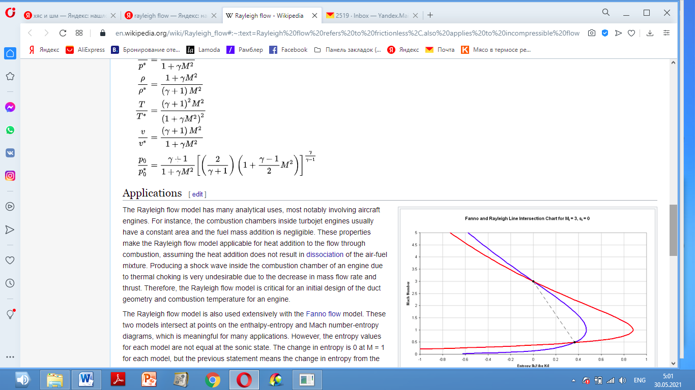

As typical application of a week solution for the Rayleigh flow model we show one dimensional unsteady case, following by Ladyzhenskaya’s methodology [7]. The conservation energy law has the view



Here and below conventional variables are used. After differencing we lightly have

 (1)

When η и λ → 0 the relation (1) gives

 (2)

For week solutions the equation (2) can be divided on two equations for entropy growth

 (3)

and total pressure losses

 (4)

We can see closed connection between the entropy growth (the relation (3)) and total pressure losses (the relation (4)). If σ = 0 applying the multiple 1/T we get from (3) the additional law of entropy conservation

$$\frac{ds}{dt}=0.$$

Although the method was shown here to deal with one dimensional problem it may be used to construct solutions of initial value problems for simulations in any number of space variables at aerodynamic heating.

Now we can introduce aerodynamic heating as specific integral heat value *δQ* in right part of energy conservation law (2) and considerate corresponded advance week solutions of hydrodynamic equations. Dividing *δQ =δQ1+ δQ2* we have





demonstrating closed connection between entropy growth at presence *δQ1* and inextricably related total pressure losses at presence *δQ2* .

The conservation energy law for unsteady Rayleigh’s flow is

 (5)

The law (5) hold true for any dimension case.

## 1.2 Diagrams for Rayleigh’s flow

We also illustrate this process by demonstrating the change in the total pressure. Figure 1 shows the heat supply diagram in the Brayton cycle for the one-dimensional case in the same plane (p, 1/ρ) under relations (2) - (4) and the total pressure loss. The segment ОА corresponds to a constant total pressure as heat Q is supplied. The segment ЕС corresponds to the supply of the same amount of heat Q to the moving flow without the total pressure loss (an analog of Riemann's error). The segment ЕG corresponds to the real-life heat supply process with the total pressure loss. The segment ОВ shows the change in the total pressure loss for the heat supply process with the total pressure loss, and the line АВ corresponds to the constant deceleration pressure; the curves e, f, and g are adiabatics.

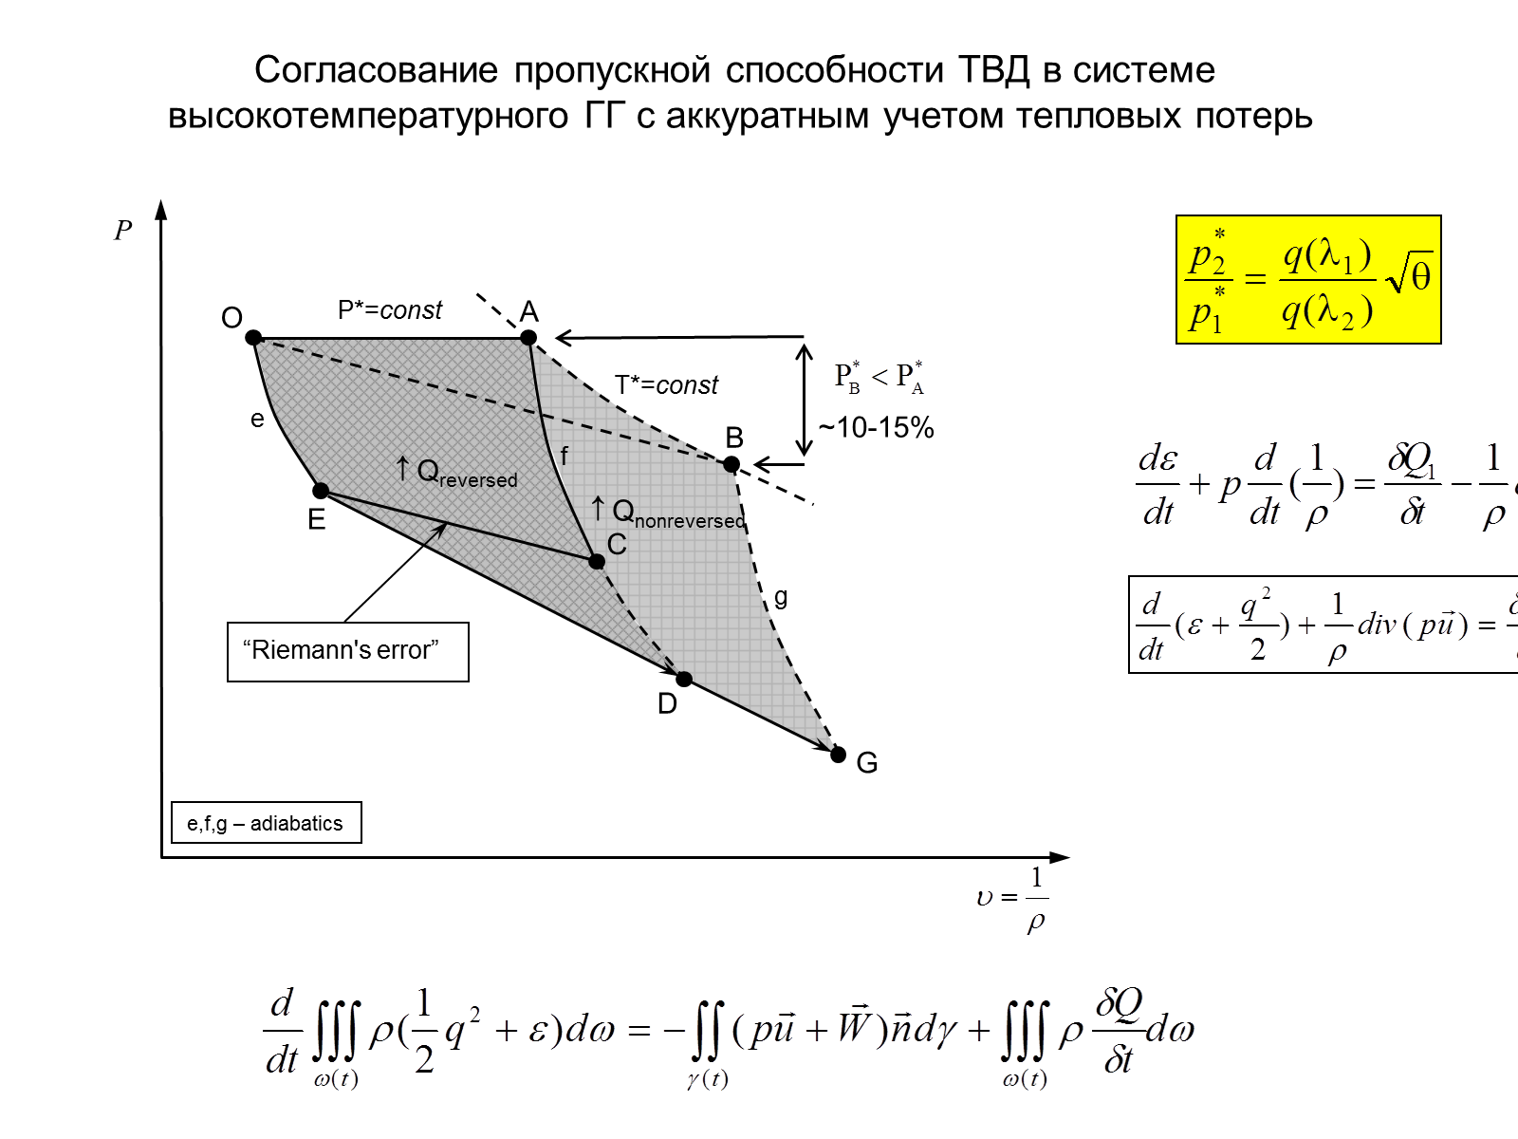

Figure 1 – Diagram of heat supply in the plane (p, 1/ρ).

The fact that the design of the core engine units in modern and promising high-temperature bypass turbofan engines requires the use of high compression ratios is explained by these considerable losses.

# Entropy Growth Simulation

## Some Experimental Data

The growth of entropy determines the energy part, which is dissipating in external space, in particular, as thermal radiation energy. We consider in detail thermal radiation of supersonic jets and internal shocks. It should be emphasized that a non-equilibrium radiation associated with the chemical reactions of fuel combustion in our cases gives a little contribution to the cumulative intensity of emission (thermal radiation) since chemical reactions to this points almost ended. The cumulative intensity of this radiation can be approximately estimated by the well-known law by the Stefan-Boltzmann *U=εσT4*.

With special experiments we have shown that a visible eye glow shock waves and the glow of the jet occurs at a sufficiently high temperature braking of the gas flow - in excess of 1000 K, and this glow can match the traditional equilibrium of a continuous thermal radiation spectrum (the spectrum of blackbody radiation).

First of all we present well known black-body spectrum for various temperatures (Fig.2). For temperature T < 1000 K spectral radiant region lies out of visible region. The eyes light registration of shock waves may be only at more temperature values. With special experiments we have shown that a visible eye glow shock waves and the glow of the jet occurs at a sufficiently high temperature braking of the gas flow - in excess of 1000 K, and this glow can match the traditional equilibrium of a continuous thermal radiation spectrum (the spectrum of blackbody radiation).

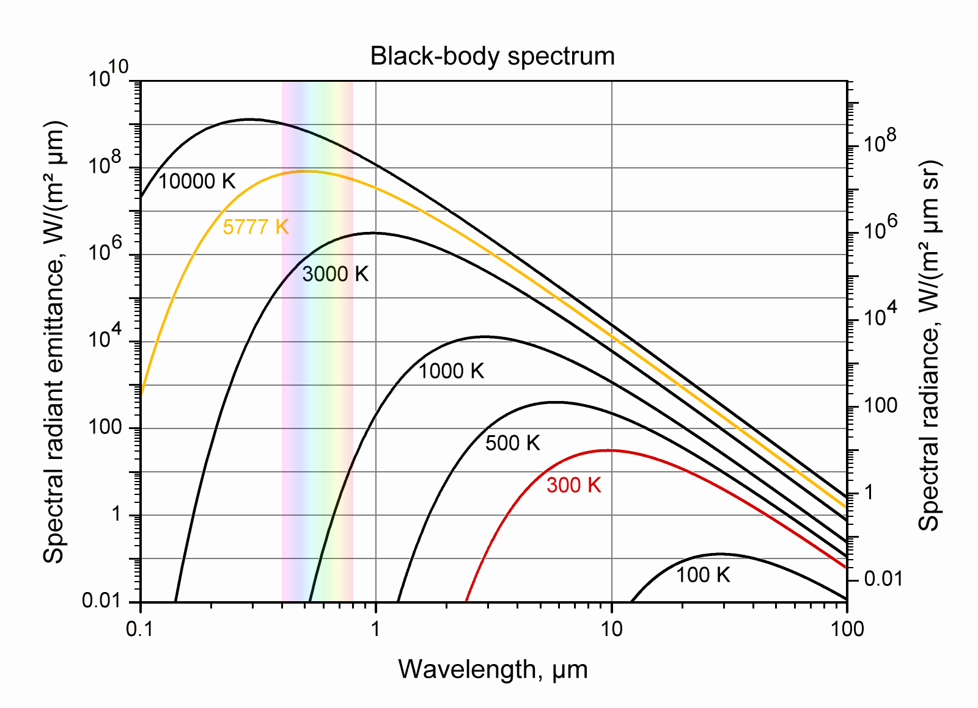

Visible light

Figure 2 – The black-body spectrum for various temperatures.

The experiment was carried out at the high temperature test cell CIAM in the temperature range 500 – 2500 K and at pressures of several atmospheres. High temperature off-design supersonic jet with the Mach number at the nozzle exit M0=1.3 in the flooded outer space with the usual atmospheric pressure. When the stagnation temperature of the flow was below 1,000 K in jet, the jet lighting is not observed. When the stagnation temperature was near 2000 K the luminous jet was in the visible range and we can see the radiate hot boundaries. Typical photo of a glowing test jet is shown in Fig.3. Clearly visible two of the Mach disk, the first three "barrel" of the jet and its external borders. The usual spectrum of the equilibrium thermal radiation meets the surroundings in the visible range at temperatures of about 2000 K.

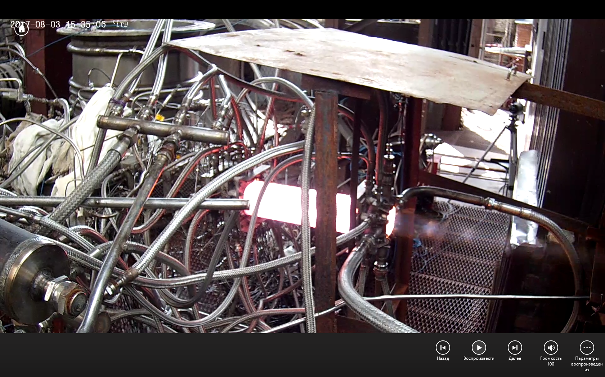

Figure 3 – Photo of thermal radiation shock waves in high temperature test jet.

## 2.2 Entropy growth in conservation law system

It is known that the basic laws of mechanics, laws of electrodynamics and quantum mechanics are reversible in time. Change the character at the independent variable t on -t does not alter the equations of motion, expressing these laws. Said effectively means that any elementary physical process, describing these laws can be made as time progresses in the forward direction (from the past to the future), and returned direction.

At the same time, the direction of time flow strictly allocated for irreversible physical processes. Equations, including description of diffusion of a substance, the dissipation of momentum, a heat and any energy losses are irreversible in time. Change the character at time t on -t leads to other equations of motion with opposite signs of diffusion coefficients, viscosities and thermal conductivity. Thus, natural physics processes have a specified irreversible time. In the most general form of thrust in time of irreversible processes expresses the law of entropy growth.

Let us now give a careful theoretical analysis of the problem of entropy growth and show the inextricable connection between the increase in entropy in adiabatic processes and the loss of the total pressure of the working medium of the process under consideration. In this case, we will use the full system of the original conservation of mass, momentum and common energy (internal and kinetic). We have balance integral equations [8,9] for a time-constant volume ω with the boundary γ in the form



 (6)



This system of equations is a thermodynamically consistent system of integral conservation laws that allows us to determine the value of heat losses (total pressure losses) when heat is supplied to a moving gas stream.

The integral law of energy conservation leads to the differential law

 (7)

The differential relation (7) in divergent form is valid for week solutions of gas dynamics equations. When performing the continuity equation, reducing by ρ and moving to the full derivative, we come to the relation

 (8)

This form is taken by the differential law of energy conservation in the case of smooth solutions. Taking into account the continuity equation, the relation (8) is easily reduced to the form

 (9)

Relation (9) shows that the heat applied to a medium moving is spent on increasing the specific internal energy, changing the work (term), changing the specific kinetic energy (with speed), and changing the value .

**3. Examples of Simulation for Week Solutions with Heating**

## 3.1 Air-Breathing Engines

We illustrate discussed above weak solutions using the calculation of the thermodynamic process in the flow passage of air-breathing engines that use the Brayton cycle. The computation thoroughly took into account all significant losses and thermal emission. Figure 4 shows the flow pattern in the form of Mach number constant lines in the flow passage of a ramjet without heat supply (а) and under the intensive heat supply (b). Under the intensive heat supply, the flow with a system of compression shock jumps into the air inlet is realized in the flow path of the combustion chamber.

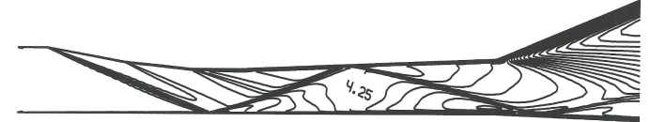

**(а)**

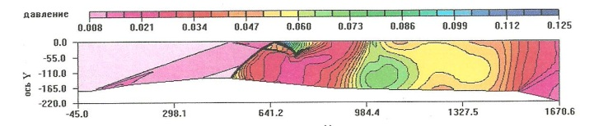

**(в)**

Figure 4 – Mach number constant lines in the absence of combustion (a) and under the engine operating conditions with combustion (b).

The next results refer to simulating the process realized after a combustor in the complete path of an aviation gas turbine consisting of a one-stage high pressure turbine, two-stage low pressure turbine, and an output diffuser. Figure 5 shows the pattern of the velocity distribution along the engine flow passage. The computation thoroughly took into account the total pressure loss.

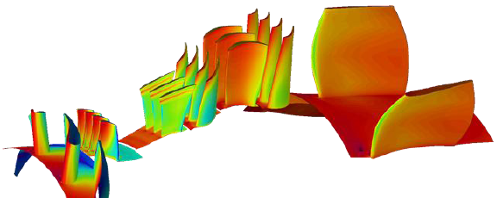

Figure 5 – Pattern of velocity distribution in the turbine flow passage.

The described above approaches were used also for investigation of steady and unsteady working points of the bypass gas turbine engine (fig. 6). The engine was investigated in detail experimentally. Both the whole engine and the core engine were tested. Different design and off-design working points were studied and compared with the test results. The experiments demonstrated significant discrepancy between the tested and design engine parameters for a number of working points in cases if considered radiate effects don’t include into account. When we have integrated the system (6) the correlation between numerical and experimental data was more satisfactory.

 

Figure 6 – Example of flow simulations in small bypass gas turbine engine.

The fact that the design of the core engine units in modern and promising high-temperature bypass turbofan engines requires the use of high compression ratios is explained by these considerable losses. Presently, these losses are most often ignored in the thermodynamic calculations of turbofan engines.

3.2 Reentry Shuttle Problems

In this section, we present weak solutions with aerodynamic heating for external reentry shuttle problems. Flow structure and surface temperature distribution for two typical shuttles show on Fig.7. On simulate regime the flight Mach number equals 5 with the angle of attack 5° (see, in detail, in [10]).

C:\Users\Ivanov\Desktop\Воронеж-14\Фигуры\Рисунок2.tif 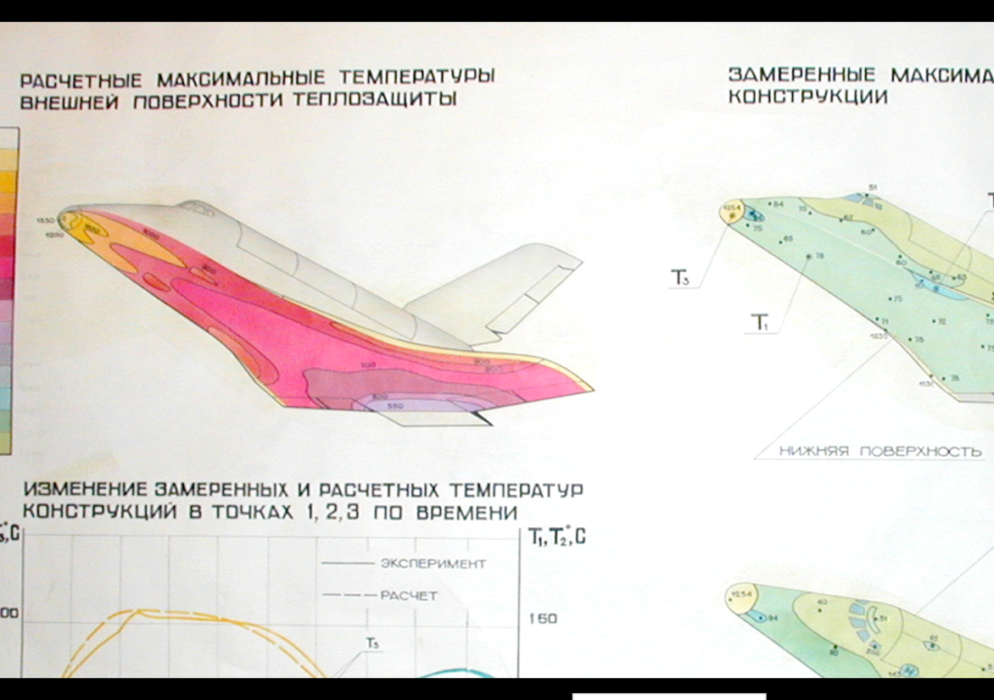

Figure 7 – Flow structure and surface temperature distribution for two typical shuttles.

# Conclusion

Week solutions describe the irreversibility effect of thermal processes and total pressure losses. They should be carefully taken into account when solving applied aerothermodynamics problems. In particular, the analysis helps justify the choice of design parameters for new high-temperature air breathing engines that use the Brayton cycle and external reentry shuttle problems.

# Contact Author Email Address

mailto: [mikhivan@yandex.ru](mailto:mikhivan@yandex.ru)

# Copyright Statement

The authors confirm that they, and/or their company or organization, hold copyright on all of the original material included in this paper. The authors also confirm that they have obtained permission, from the copyright holder of any third party material included in this paper, to publish it as part of their paper. The authors confirm that they give permission, or have obtained permission from the copyright holder of this paper, for the publication and distribution of this paper as part of the ICAS proceedings or as individual off-prints from the proceedings.

# References

1. Lax, P. D., Weak solutions of nonlinear hyperbolic equations and their numerical computation, Communs. Pure and Appl. Math., Vol. 7, pp. 159–193, 1954.
2. Lax, Peter D. [Numerical solutions of partial differential equations](http://www.maa.org/programs/maa-awards/writing-awards/numerical-solutions-of-partial-differential-equations). Amer. Math. Monthly, vol. 72, Part II (2): pp. 78–84, 1965.
3. Godunov S.K. The concept of generalized solutions. Reports of Acad. of Sci. USSR, 1960, vol. 134, no. 6, pp. 1279–1282.
4. Godunov, S. K. A Difference Scheme for Numerical Solution of Discontinuous Solution of Hydrodynamic Equations, [Math. Sbornik](https://wiki2.org/en/Matematicheskii_Sbornik),1959, vol. 47, pp.271-306, translated US Joint Publ. Res. Service, JPRS 7225 Nov. 29, 1960.
5. Landau, L.D., Lifshitc, E.M. Statistical Phys. Theor. Phys. Vol. X. M; Nauka. 1996, 504p.
6. Ginzburg, V.M. Advance of Physics Science, 1999, Vol.189, p. 46.
7. Ladyzhenskaya O. A.. On the construction of discontinuous solutions of quasilinear hyperbolic equations as limits of solutions of the corresponding parabolic equations when the "viscosity coefficient" tends to zero. Reports of Acad. of Sci. USSR, vol. 111, No. 2, 1956, pp. 291—294.
8. Ivanov, M.Ja., Mamaev, V.K. & Zhestkov, G.B. (2014). Thermodynamically compatible theory of high temperature turbojet engines. In Proc. 29th ICAS, 7-14 Sept., St.-Petersburg.
9. Ovsiannikov LV. Lectures on gas dynamics bases. Nauka, Moscow. 1981;368.
10. Godunov SK, Zabrodin AV, Ivanov M. Ja, Kraiko AN, Prokopov GP. Numerical solution of multi-dimensional gas dynamic problems. M: Nauka. 1976;400.