Supplementary materials

**INTERACTION OF PLATINUM WITH ANTIMONY-BEARING COMPOUNDS IN NaF FLUIDS AT 800 °C AND 200 MPA.** Physics and Chemistry of Minerals. Alexander F. Redkin1, Andrey M. Ionov2, Alexey N. Nekrasov1, Andrey D. Podobrazhnykh3, Rais N. Mozhchil2

*1* Academician D.S. Korzhinskii Institute of Experimental Mineralogy RAS, Chernogolovka, Moscow District, 4 Academician Ossipyan str., 142432 Russia

*1* Phone: 007-49652-25852;-Fax: 007-49652-44425; e-mail addresses: [redkin@iem.ac.ru](mailto:redkin@iem.ac.ru), URL: [www.iem.ac.ru](http://www.iem.ac.ru)

*2* Institute of Solid State Physics RAS, Chernogolovka, Moscow District, 2 Academician Ossipyan str., 142432 Russia

*2* *Phone: 007-49652-25496; Fax: 007-49652-28160; E-mail address:* [ionov@issp.ac.ru](mailto:ionov@issp.ac.ru); *URL:* [www.issp.ac.ru](http://www.issp.ac.ru)

*3* Geology Department of the M.V. Lomonosov Moscow State University, Moscow, Russia

*3 E-mail address:* [andrew.podobrazhnykh123@gmail.com](mailto:andrew.podobrazhnykh123@gmail.com), *URL:* [www.geol.msu.ru](http://www.geol.msu.ru)

E-mail address of the corresponding author: [redkin@iem.ac.ru](mailto:redkin@iem.ac.ru), URL: [www.iem.ac.ru](http://www.iem.ac.ru)

Supplementary materials include phase diagrams in the Pt-Sb system by various authors in the temperature range 500–900 °C, containing from 0 to 50 at% Sb, which demonstrate a wide range of data on the temperature stability of the Pt-Sb phases. The composition of the newly formed Pt5Sb phase at 800 °C is shown in the figures S1-S9.

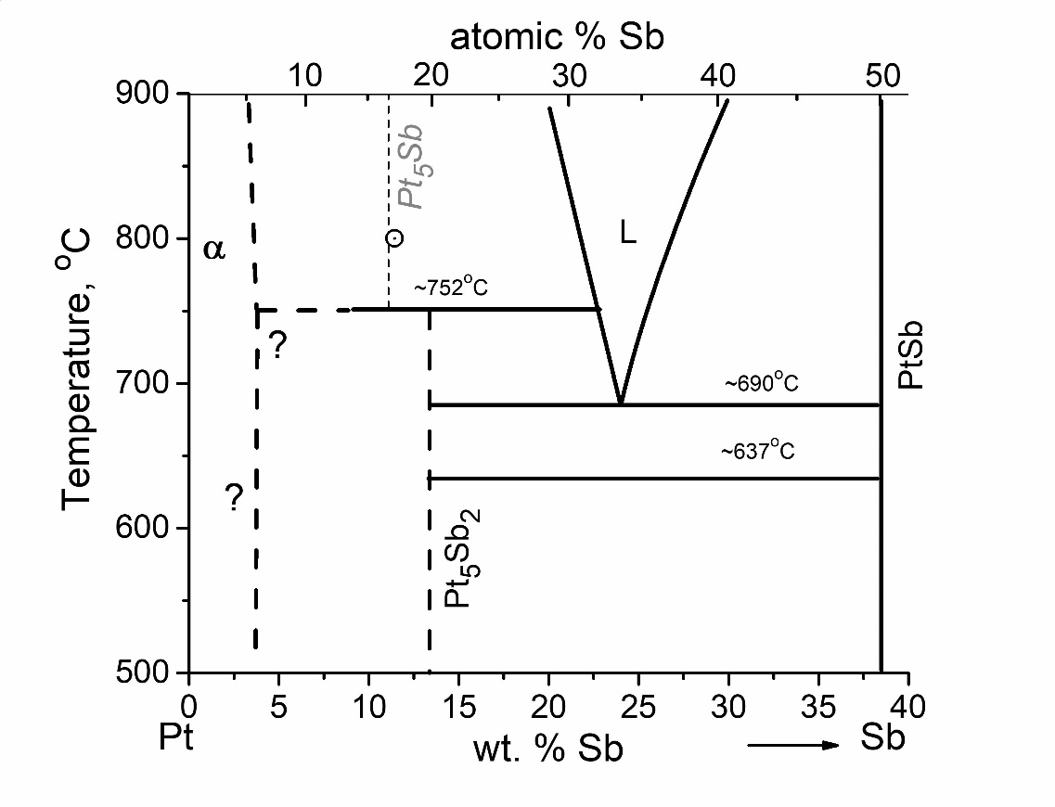

**Fig. S1.** Phase diagram in the Pt-Sb system according to (Hansen 1936; Hansen and Anderko 1958).

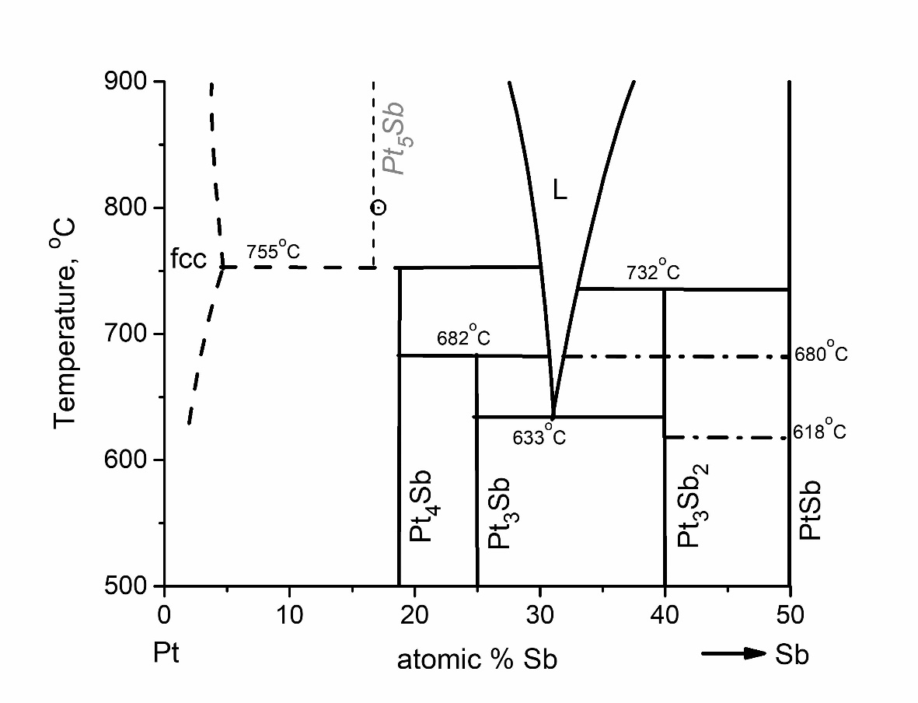

**Fig. S2.** Phase diagram in the Pt-Sb system according to (Bhan et al. 1969).

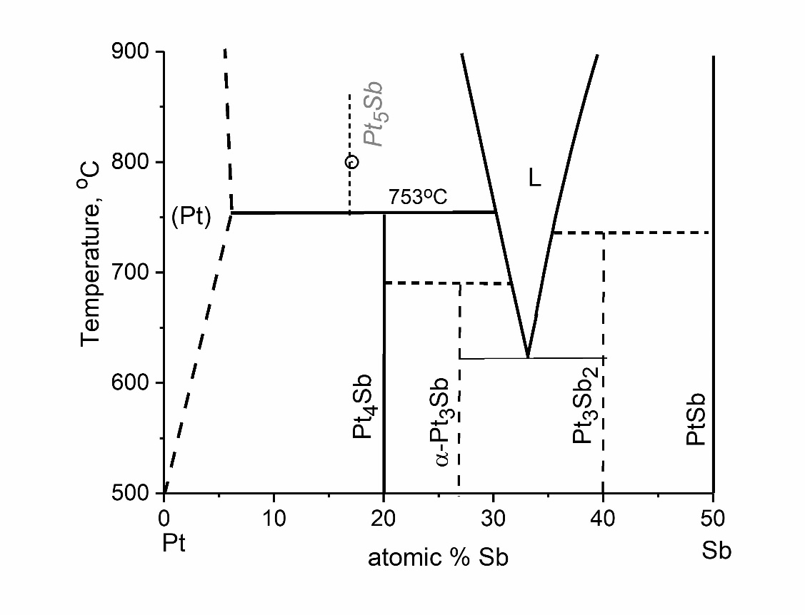

**Fig. S3.** Phase diagram in the Pt-Sb system according to (Srivastava et al. 1972).

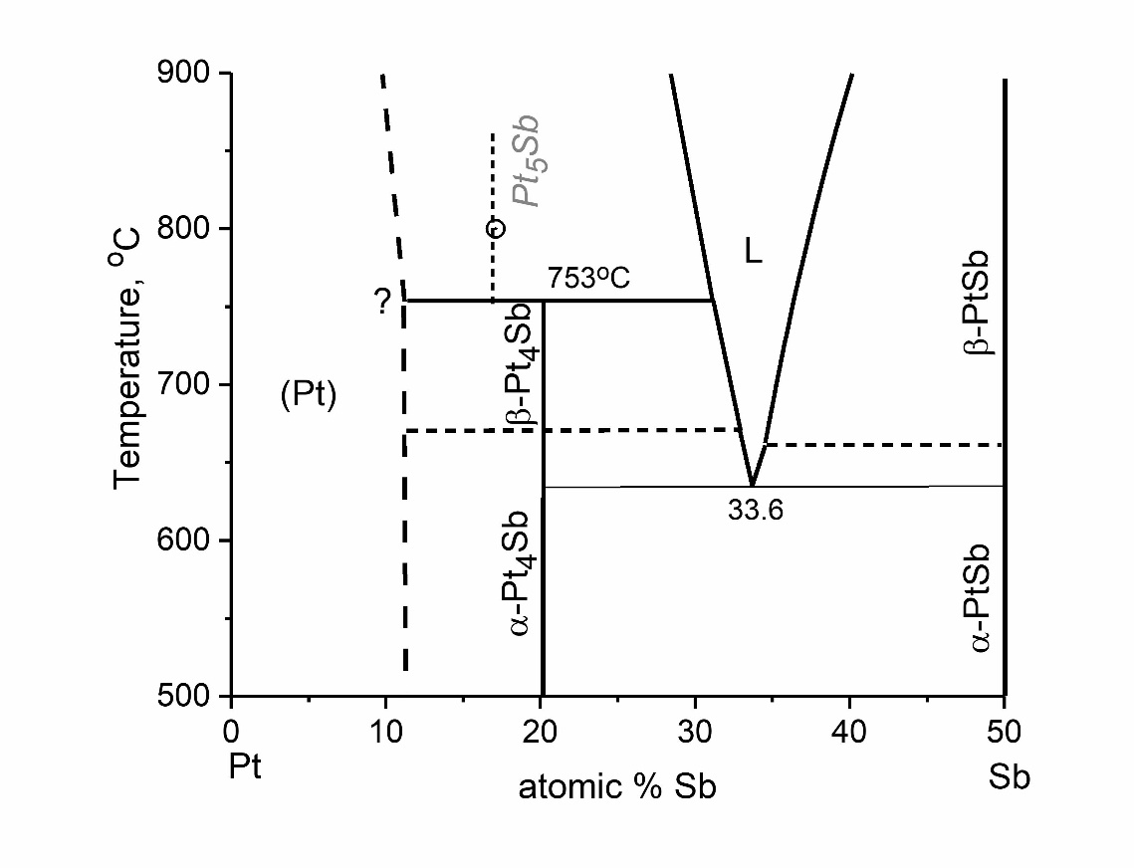

**Fig. S4.** Phase diagram in the Pt-Sb system according to (Massalski et al. 1986)

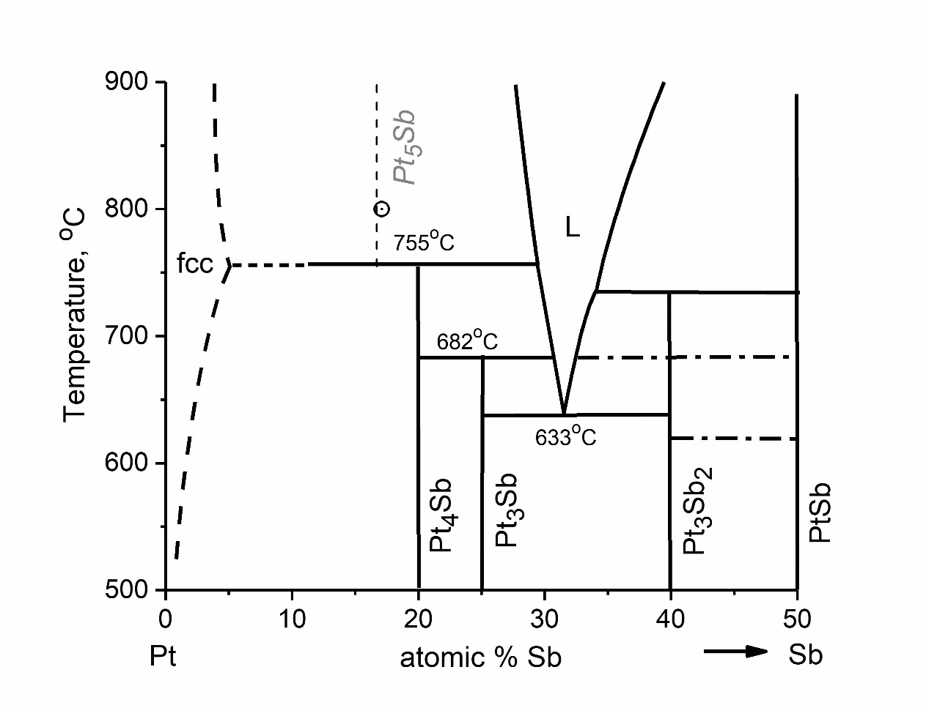

**Fig. S5.** Phase diagram in the Pt-Sb system according to (Kim 1988). fcc-face-centered cubic structure.

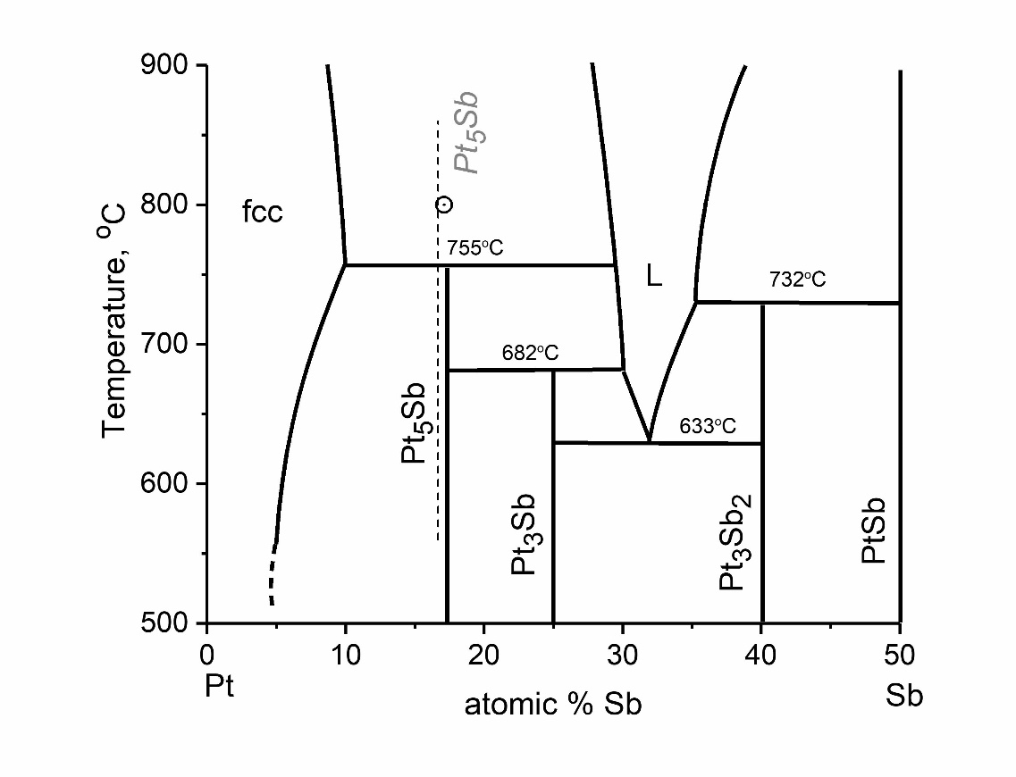

**Fig. S6.** Phase diagram in the Pt-Sb system according to (Kim and Chao 1990; Kim 1993).

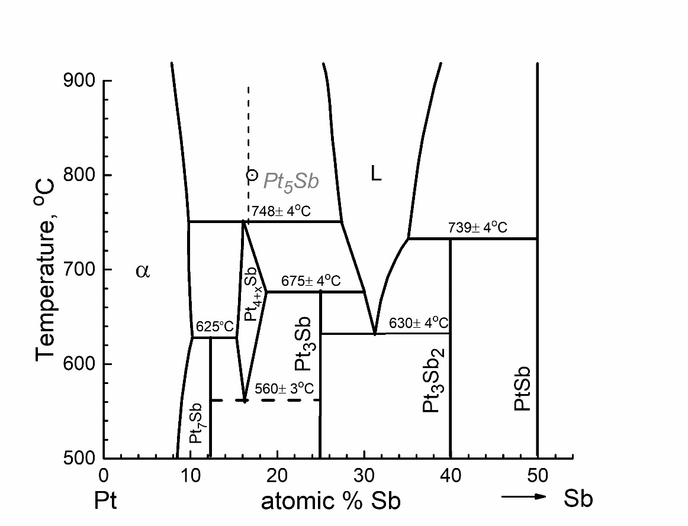

**Fig. S7.** Phase diagram in the Pt-Sb system according to (Duruselle and Feschotte 1991, Okamoto 1992; Itkin and Alcock 1996).

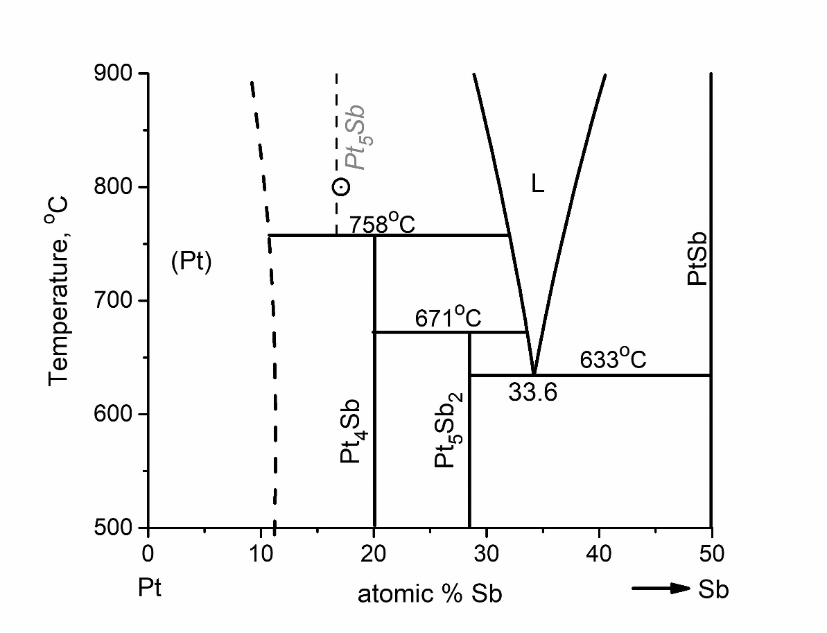

**Fig. S8.** Phase diagram in the Pt-Sb system according to (Lyakishev 2000).

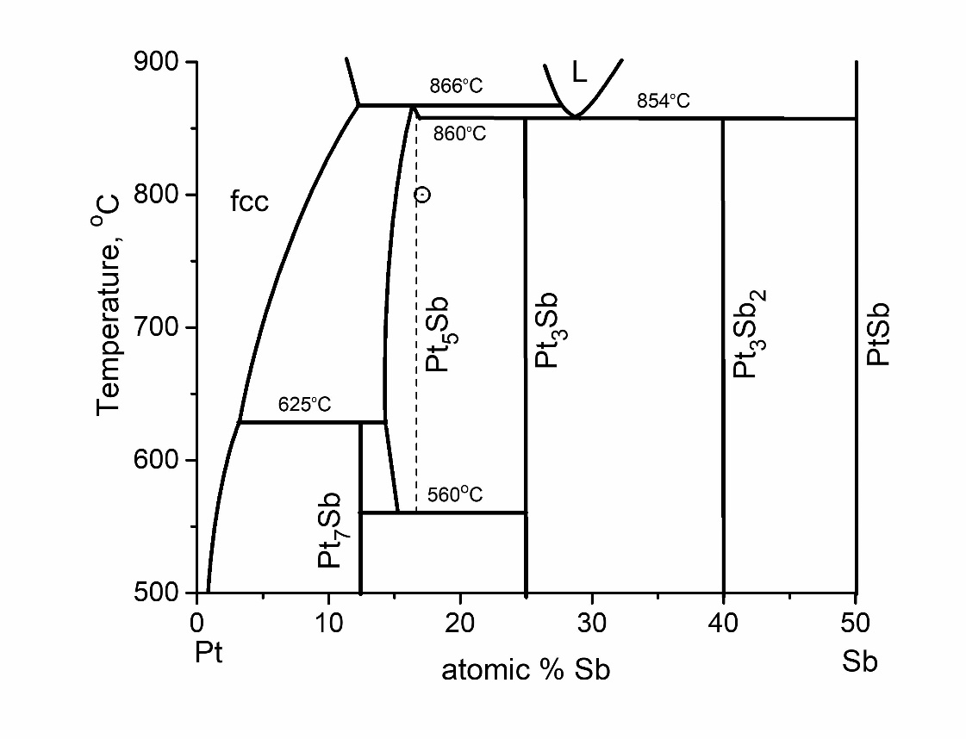

**Fig. S9.** Phase diagram in the Pt-Sb system according to (Liu et al. 2013): fcc – face-centered cubic Pt5Sb (*cP*4 or *Fm $\overline{3}$ m*) with more homogeneity ranges 0.155 – 0.189 Sb will treated as solid solution compound.

**References**

Bhan S, Gödecke T, Schubert K (1969) Konstitution einiger mischungen des platins mit b-elementen (B = Sn, Sb, Te). J Less-Common Met 19(2):121–140. <https://doi.org/10.1016/0022-5088(69)90027-7>

Durussel Ph, Feschotte P (1991) Les Systèmes Binaires Pd-Sb et Pt-Sb. J Alloy Compd 176(1):173–181. <https://doi.org/10.1016/0925-8388(91)90023-O>

Hansen, M. (1936) Der Aufbau der Zweistofflegierungen. Eine kritische Zusammenfassung. Springer-Verlag Berlin, Heidelberg. 1100 p. <https://doi.org/10.1007/978-3-642-47516-0>

Hansen M, Anderko K (1958) Constitution of binary alloys. 2 nd ed., New York, McGraw-Hill Book Co., NY. 1305 p.

Itkin VP, Alcock CB (1996) The Pt-Sb (platinum-antimony) system. J Phase Equilib 17:356–361. <https://doi.org/10.1007/BF02665564>

Kim W-S (1988) Phase Constitution of the Pt-Sb System. J Korean Inst Met26:378-384.

Kim W-S (1993) Phase and phase equilibria in the Pt-Sb system. J Korean Inst Mining Geol 26(3):18–24.

Kim W-S, Chao GY (1990) Phase relations in the system Pt-Sb-Te. Can Mineral 28:675–685.

Liu J, Zhang Y, Guo C (2013) Thermodynamic Assessment of the Pt-Sb System. International Journal of Nonferrous Metallurgy 2:95–99. <https://doi.org/10.4236/ijnm.2013.23013>

Lyakishev (2000) State diagrams of binary metallic systems(2000) Reference book: In 3 volumes: V. 3. Book. 2. Under the general ed. N.P. Lyakishev. Moscow: Mechanical Engineering, 2000. 448 p. ISBN 5-217-02932-3

Massalski TB, Murray J.L., Bennett L.H., and Baker H. (1986). Binary Alloy Phase Diagrams, Vol 1 and 2, American Society for Metals, Metals Park, OH. 2224p.

Okamoto H (1992) Pt-Sb (Platinum-Antimony). J Phase Equilib 13(5): 580–581. <https://doi.org/10.1007/BF02665778>

Srivastava PK, Giessen BC, Grant NJ (1972) A noncrystalline Pt-Sb phase and its equilibration kinetics. Metall Trans 3:977–982. <https://doi.org/10.1007/BF02647675>